Pisa, Lucca, Florence, Verona, Venice & Lake Garda
Saturday 23rd – Thursday 28th May 2015

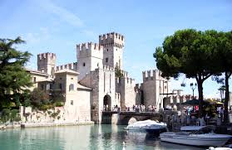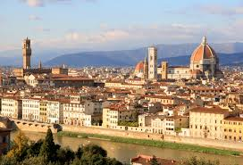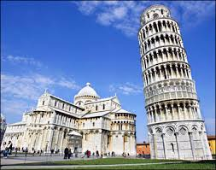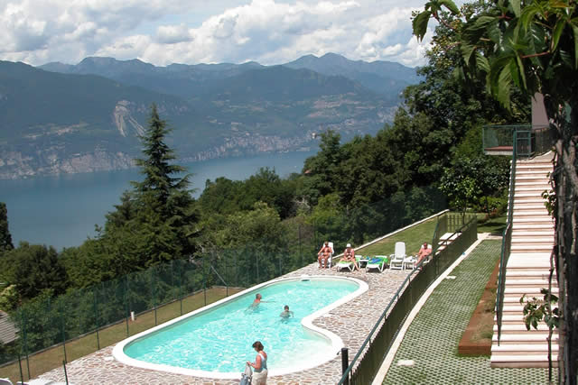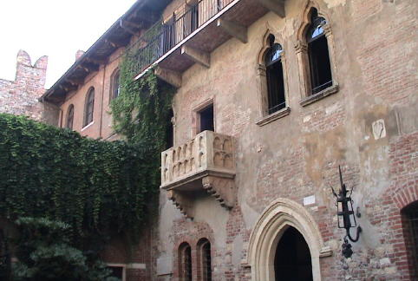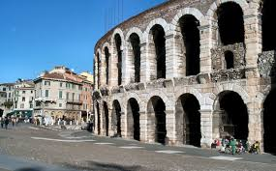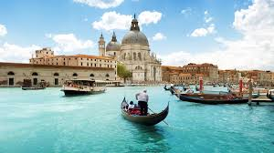

Day 1 – Saturday 23rd May 2015
02h30 Meet Donoghue’s Bus in Kells at the Church at 2.30am SHARP.
03h45 Assemble at Dublin Airport Terminal 1 and proceed to the allocated bag drop desk for luggage check in. Once your bags have been checked in proceed through security with your boarding passes.
1 ITEM OF CHECKED LUGGAGE (MAX 15KG)
1 ITEM OF HAND LUGGAGE (MAX 10KG)

06h15 Depart Dublin Airport on your scheduled flight FR 9428 to Milan Bergamo Airport
09h45 Arrive at Milan Bergamo Airport, collect luggage and meet coach and begin your Italian adventure. Continue to Leaning Tower of Pisa with a short stop en route for lunch at own expense.
15h30 Depart Pisa for Lucca. On arrival in Lucca enjoy a walk around the famous walls dating back to the sixteenth century before entering into the enchanting city centre. Sights to see include Piazza dell'Anfiteatro, built on the ruins of the Roman amphitheatre, the shopping street of Via Fillungo, the monumental square of Piazza Napoleone and the medieval tower, Giunigi tower, whose roof is topped with a garden. Enjoy FREE time and dinner in Lucca at own expense.
20h00 Meet coach and continue to hotel for check in and overnight stay.

Hotel Details:
Hotel Carignano,
Via di Sant' Alessio 3680,
55100 Carignano,
Province of Lucca
Tel: 00 39 0583 329618

Room Configuration:
Students: 5 Quads, 3 Triples

Day 2 – Sunday 24th May 2015

08h00 Enjoy breakfast at your hotel
09h00 Depart your hotel and travel to Florence, approx. 1 hour 30 minutes journey time.
11h00 Meet your guides for your Florence City Tour and Guided Tour of the Uffizi Gallery
The Uffizi Gallery is one of the most important museums in the world for Italian art and, in particular, art of the Renaissance. All of the famous names from Italy's rich artistic heritage, including Leonardo da Vinci, Giotto, Michelangelo, Botticelli, Piero della Francesca, Caravaggio, and Raphael, are represented at the Uffizi. Enjoy a guided walking tour of the city. Sights to see on your tour include Ponte Vecchio, Palazzo Vecchio, Piazza del Duomo, Florence Cathedral, Piazza delle Signoria & Basilica Sante Croce.
14h30 Enjoy some FREE time to explore Florence and dinner at own expense in Florence.
18h30 Return to Lucca, approx. 1 hour 30 minutes journey time
20h00 Return to the hotel for overnight stay and pack as that is the last night in this hotel.

Day 3 – Monday 25th May 2015

07h00 Enjoy breakfast at hotel and check out.
08h00 Depart hotel for Gardaland, approx. 3 hours journey time. With 6 roller coasters and a total of 32 rides you will be spoilt for choice! Enjoy lunch at own expense
18h00 Depart Gardaland for your hotel for check in, evening meal and overnight stay.

Hotel Details:
Hotel San Zeno
Via Contrada Castello, 55,
37010 San Zeno di Montagna VR, Italy
+39 045 728 5031

Room Configuration:
Students: 6 Quads, 1 Triple, 1 Twin

Day 4 – Tuesday 26th May 2015

08h00 Enjoy breakfast at your hotel
09h00 Depart hotel for Verona, approx. 1 hour journey time. Short walking tour of Verona and enjoy lunch at own expense. Free time to explore the lovely city with such sights as the Roman Arena originally built in 30 AD, it is world famous for holding large scale opera shows and is one of the best preserved ancient structures of its kind. Entrance Rate: €5 per person optional extra and Juliet’s House where the famous balcony can be seen. Entrance Rate: €5 per person optional extra

14h00 Depart Verona for Sirmione, approx. 1 hour 15 minutes journey time. Enjoy a boat trip on the lake in Sirmione and some FREE time to explore Sirmione.
18h00 Return to your hotel, approx. 1 hour 30 minutes journey time, for evening meal and overnight stay.

Day 5 – Wednesday 27th May 2015

07h30 Enjoy breakfast at your hotel.
08h30 Meet your coach and driver at the hotel and continue for Venice, approx. 2 hours journey time. Take the ‘Vaparetto’ or water bus from Tronchetto to the city centre. Travel time to St. Mark’s Square is approx. 45 minutes .
11h00 Enjoy a guided walking tour of Venice taking in the historical and artistic outline of St Mark’s Square, St Mark’s Basilica, the Doges Palace, Bridge of Sighs & Ponte Rialto.
17h30 Depart St. Mark’s Square by return Vaporetto to meet coach at the buspark (Tronchetto)
18h00 Return to your hotel for evening meal and overnight stay, approx. 2 hours journey time.

Day 6 – Thursday 28th May 2015

08h00 Enjoy breakfast at your hotel and check out.
09h00 Depart for Caneva Aquapark, approx. 1 hour journey time and enjoy a fun filled day.
15h30 Depart Caneva Aquapark to the Orio Shopping Centre at Milan Bergamo Airport, approx. 1 hour 30 minutes journey time.
19h00 Continue to Milan Bergamo Airport
19h25 Assemble at Milan Bergamo Airport and proceed to the allocated bag drop desk for luggage check in.
1 ITEM OF CHECKED LUGGAGE (MAX 15KG)
1 ITEM OF HAND LUGGAGE (MAX 10KG)

21h55 Depart Milan Bergamo Airport on your scheduled flight FR 4845 to Dublin Airport Terminal 1
23h30 Arrive at Dublin Airport Terminal 1 and collect luggage at the allocated belt
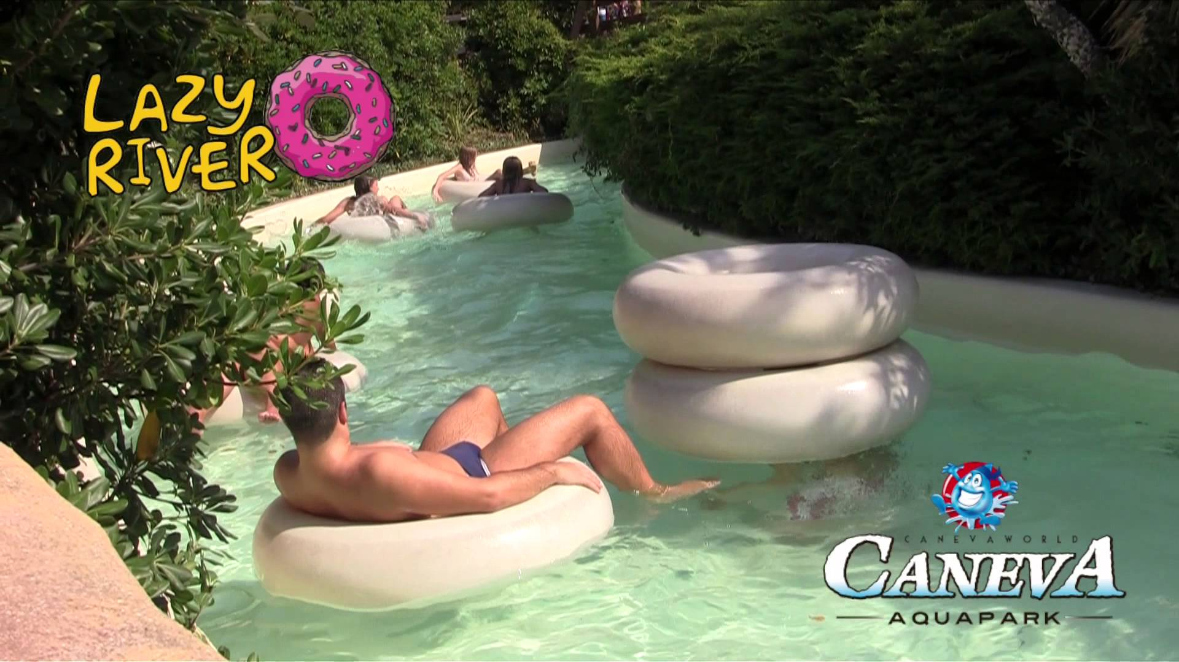
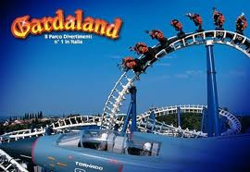
01h30 Approximate arrival time in Kells is 1.30am outside the Church by Donoghue’s bus.

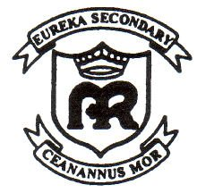
Eureka Secondary School,
Kells,
Co Meath.

Tel: 046-9240132

Email: office@eurekaschool.ie
Website: www.eurekasecondaryschool.ie

15/5/’14

Dear Parent/Guardian,

At this stage your daughter should have an up to date Passport and European Insurance Card. The passport is the students’ own responsibility and she will not be allowed to travel without it.

When we reach Italy we shall retain the original passports in a safe at the hotel and give a photocopy to the girls, but they are responsible for their own passports at the airports.

I have enclosed an itinerary for the trip. It is important that students drink lots of water to stay hydrated. Students should also pack for all sorts of weather, sweater for cold evenings, rain gear and suntan lotion. In previous tours to Italy we have experienced all the seasons in one week. If you have any urgent query you can contact me at the school.

The other teachers travelling with the group are, Ms O’Reilly (Principal), Ms Harte & Ms Ganley.
Below are the flights times – any changes in flight times are outside our control and students were warned at booking stage not to have any other travel planned close to those dates.

Outbound: Saturday 23rd May Dublin to Milan Bergamo
Terminal 1: Ryanair Flight FR 9428 Depart Dublin @ 06.15 Arrive Milan @9.45

Inbound: Thursday 28th May Milan Bergamo to Dublin
Terminal 1: Ryanair Flight FR 4845 Depart Milan @ 21.55 Arrive Dublin @ 23.30

Leaving Kells on Donoghues bus - outside Church at 2.30am SHARP on Saturday 23rd May.
The estimated time of arrival in Kells on Thursday 28th May sometime after 1am depending on flights running to schedule. Please keep in contact with your daughter by mobile for any changes.

Thanking you,
Ms. Mullaghy.

PLEASE NOTE:
I have home contact details for everyone if there is any problem that I need to discuss.
You have all signed that “you guarantee your daughter will abide by the appropriate code of conduct and violation of the rules will mean that the student is sent home on her own, at the parent’s expense”. Rules are there for the Health and Safety of everyone!

My mobile number while away is: 00353 87 9030727 – to be used in genuine emergency only please.

